Knowledge Transfer (KT) Document: Interactive Slideshow Feature

- Project Overview
This document provides an in-depth knowledge transfer for the Interactive Slideshow Feature developed as part of the project. It covers setup instructions, slide creation workflow, customization options, and the download/export mechanism for end-users. This document is intended to understand the entire functionality, its purpose, and how to use it end-to-end.

Project Link: https://drive.google.com/file/d/1LfCobMpJg1L7BN9646arQ5XXFABsJgMT/view?usp=sharing

- Setup Instructions
Before starting the slideshow creation process, you need to properly set up the environment:
  - Required Files
  - Download the provided ZIP file from the client or project repository.
1.2 Installation and Launch
- Unzip the file into your desired working directory.
- Inside the unzipped folder, locate the index.html file.
- Double-click on index.html to open it in your default web browser.
- The slideshow editor interface will now be launched and ready for use.
This method uses a static HTML file and does not require any server or internet connection. It runs completely locally on the user's system.

2. Initiating Slideshow Creation
2.1 Accessing the Editor
- Once the application is open in the browser, locate and click on the "+" button (usually at the top-left or toolbar).
- From the sidebar or panel labelled "Basic Options", drag and drop the "Video Interactive" component into the canvas area (editor).
This step is crucial to initialize the slideshow feature. Without this component, the slideshow workflow does not begin.
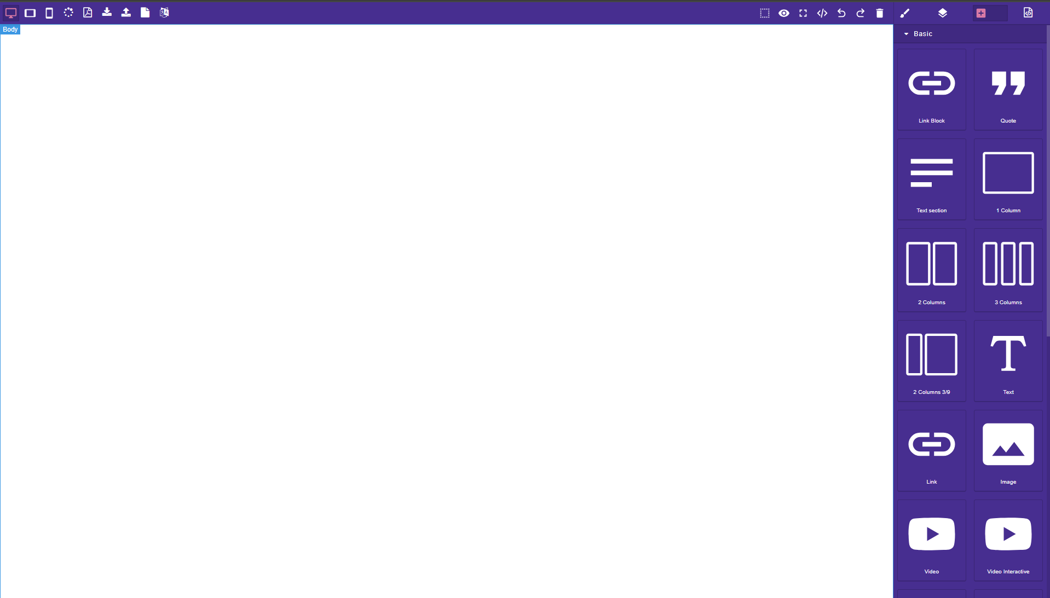

3. Slide Setup Wizard
Once the video interactive block is added, a two-step modal popup will guide you through the initial setup:
3.1 Step 1: Number of Slides
- A prompt will ask: "How many pages do you want?"
- Input a numeric value based on how many slides you want in your presentation.
- Click on the Next button to proceed.
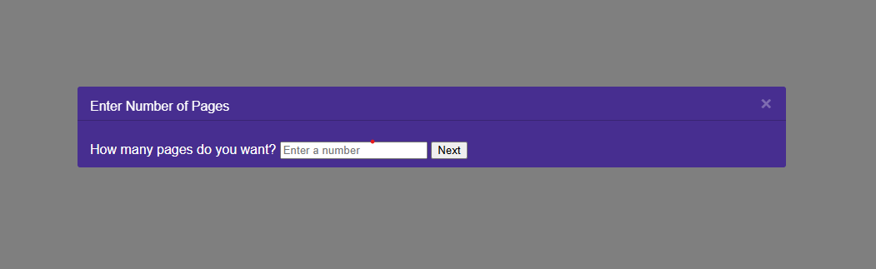

3.2 Step 2: Canvas Size Selection
You are given three options:
- A4 (Standard print size: 595px x 842px)
- 720p (Screen optimized: 1280px x 720px)
- Custom: Allows user-defined dimensions (width & height in px or %).
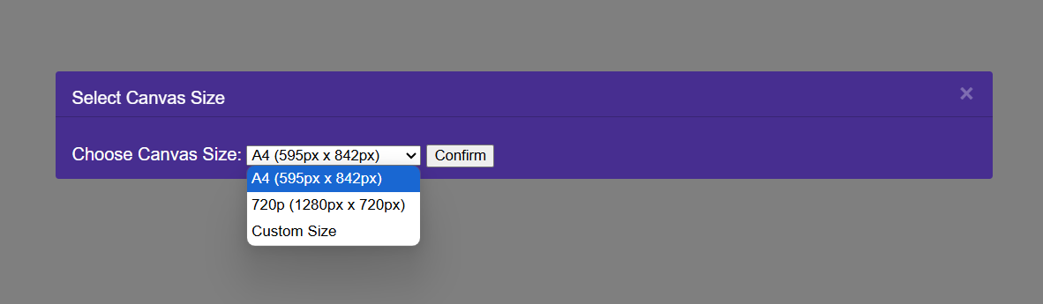
The selected canvas size applies uniformly to all slides. Once confirmed, the base structure of your slideshow is created.

4. Slide Editor Interface
4.1 Slide Display and Navigation
- The first slide opens by default in the main editor.
- All other slides appear as thumbnails at the bottom of the screen.
- The currently selected slide will appear slightly enlarged for visual indication.
4.2 Selecting Slides
- Click on any thumbnail to edit that slide.
- If you click again on the currently selected thumbnail, a configuration modal will appear to edit that slide's transition and display settings.
Thumbnails improve navigation and ensure quick access to any slide without breaking the workflow.
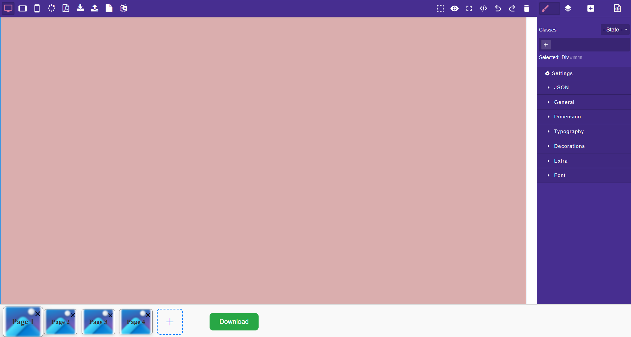

5. Slide Configuration
Upon clicking the same thumbnail twice (or selecting transition manually), a modal opens with the following settings:
5.1 Transition Settings
- Transition Type: Choose from None, Fade, Slide, or Zoom
- Transition Duration: How long the transition effect lasts (in seconds)
- Slide Timer: How long the slide stays visible before switching to the next
- Direction: Only shown if "Slide" transition is selected (Left, Right, Up, Down)
5.2 Visibility Settings
- Hide Slide: Checkbox to hide slide in exported version
- Conditional Hide (Word Match): You can specify a keyword from your JSON data. If the value is found on that slide, it will be hidden.
These settings help customize the behaviour and appearance of each slide, providing flexibility for storytelling or data presentations.
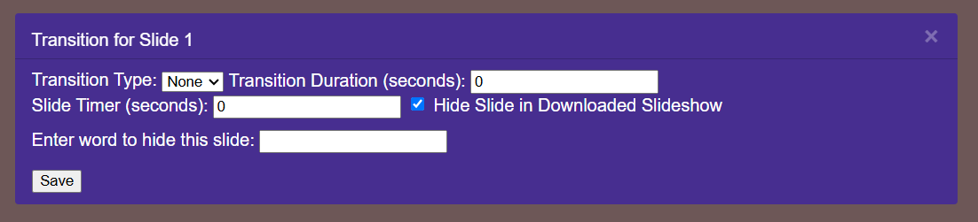

6. Slide Design and Element Integration
You can enhance each slide by dragging elements from the right-side panel. Supported elements include:
- Static images and GIFs
- Buttons and clickable components
- Tables with data support
- Input forms and text fields
- Charts or icons
Each component supports rich styling and configuration:
- Position: Move freely on the canvas ( display, position, float, etc
- Properties: Adjust via settings panel (colour, background, font, etc.)
These design tools provide full creative control to structure each slide like a frame of a video or animated scene.
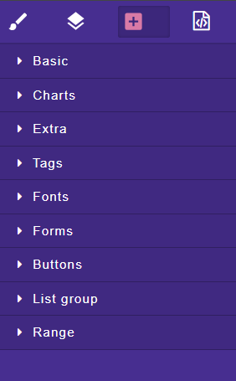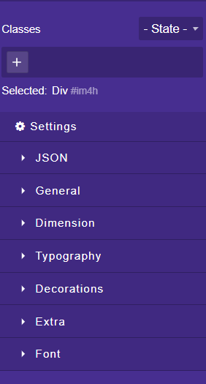

7. Download and Export Slideshow
After designing all slides, locate the Download button below the thumbnails. This button becomes visible only when the slideshow is initialized.
7.1 Download Process
- Clicking the button triggers generation of a self-contained HTML file.
- The file includes all styles, scripts, content, and transition logic.
- Automatically starts downloading with the filename: interactive_slideshow.html
This output file is portable and can be shared or hosted directly without any additional dependencies.
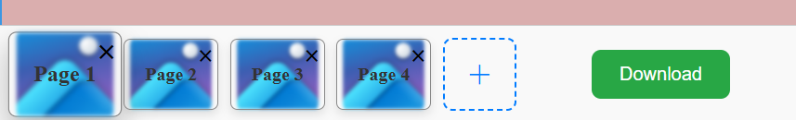

8. Downloaded Slideshow Interface
When the downloaded HTML is opened, it resembles a professional video slideshow.
8.1 Visual Elements Included
- Slide Thumbnails: Positioned horizontally above the progress bar for easy navigation
- Progress Bar: Shows real-time progress and slide boundaries
- Digital Timer: Displays elapsed time in mm: ss format
- Play/Pause Button: Located at centre-bottom for media-like control
8.2 Interactivity
- Clicking a thumbnail jumps directly to that slide and continues playback
- Clicking on progress bar seeks to the corresponding slide or timestamp
These features simulate a true video playback experience using pure HTML, CSS, and JavaScript.
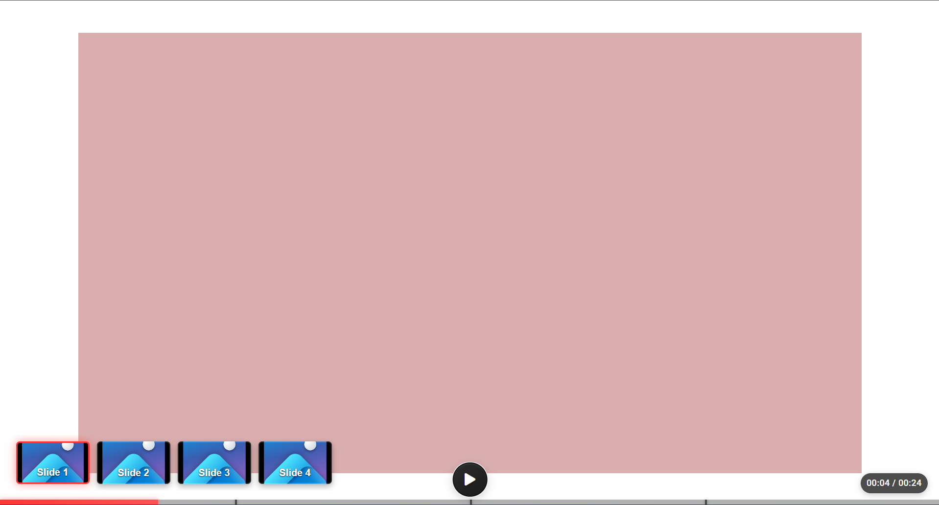

9. Thumbnail Name Editing
Users can rename each slide's thumbnail for better identification.
Double-clicking the thumbnail name at the footer opens an inline editor where the name can be updated.
This updated name reflects in the final downloaded slideshow HTML under the thumbnail navigation, ensuring consistency between editor and output.
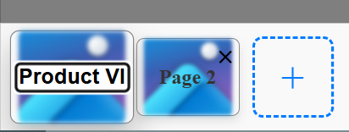

10. Hide Thumbnail in Footer
A checkbox setting labelled "Hide Thumbnails” is available in Footer.
When enabled, all thumbnails will be hidden in the slideshow playback view (in exported HTML).
This is useful when a cleaner, distraction-free presentation is required.
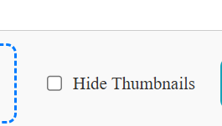

11. Upload Logic via Excel/CSV
To power dynamic logic or condition-based behavior in slides, you can upload an Excel (.xlsx) or CSV file via the backend.
These files are used to populate form inputs and drive service-based logic (such as filtering or conditional display).
Headers from the uploaded file will be used throughout the editor, especially in form element setup.
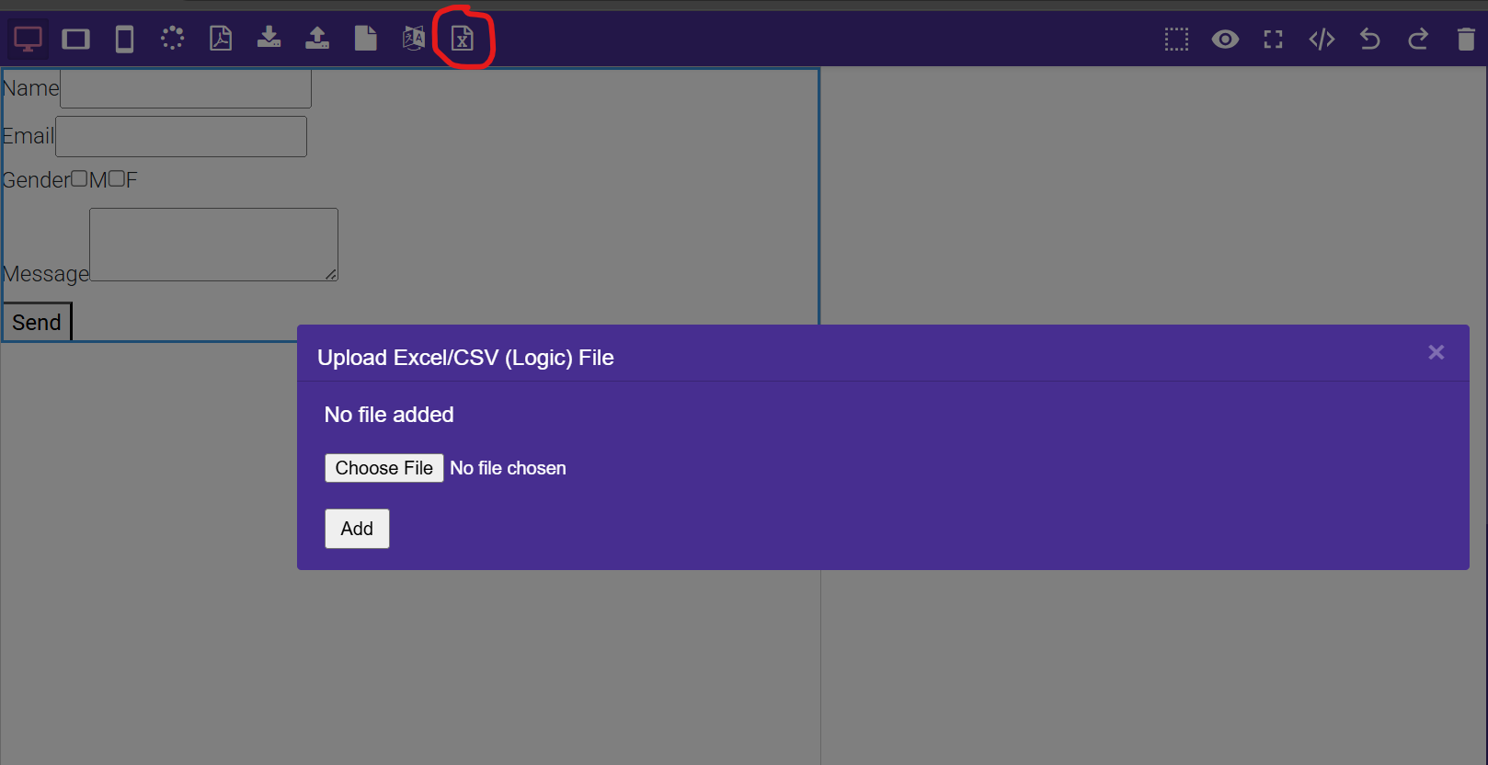

12. Logic Handling via Drag-and-Drop Form Element
To implement logic-based workflows such as service calls, conditional filtering, or dynamic input processing, a special form element is available under the Form section in the component sidebar.
Drag and drop this form element into the desired slide. This single element will handle all logic required for that slide, whether it's sending data (POST) or displaying data (GET). It acts as the core handler for logic-driven interactivity in the slideshow.
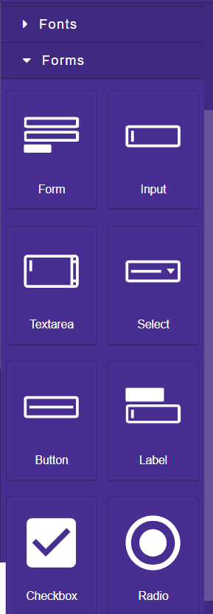
Once added to the canvas, configure the form element using the Settings panel, as follows:
For POST Logic (e.g., filter based on user selection):
- Set Method to "POST" in the form settings.
- Set Action Type to "API", which enables backend integration.
- For each input field (radio button, checkbox, dropdown, etc.):
  - Set Input Type = "API".
  - In the "Name" dropdown, you will see all column headers from the uploaded Excel/CSV file.
  - Select any header.
  - Then in the "Value" dropdown, select the unique values available under that column.
- Inside the form, there's a Button element. Make sure this button’s type is set to "submit" in the settings.
- Once configured, the user can select an option from the inputs and click "Send". This triggers a service call and filters the slideshow dynamically based on the selected logic.
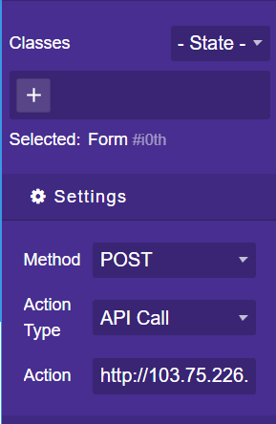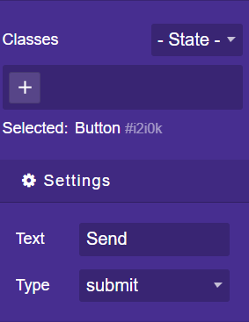
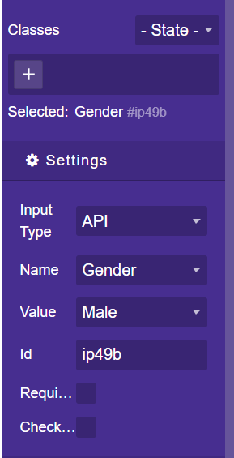

For GET Logic (e.g., display dynamic data fetched from backend):
- Again, drag and drop a form element onto the required slide.
- Set Method to "GET" in the settings.
- Inside the form, use standard input fields like text fields or textareas.
- Set Input Type = "API" for those fields.
- In the "Name" option, select the appropriate Excel header.
- This setup will auto-display data fetched from backend based on the GET API response.
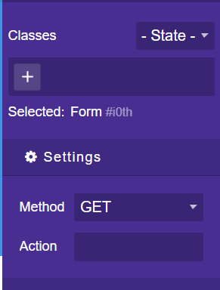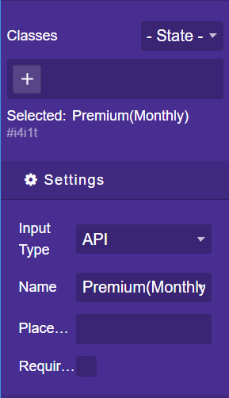
⚠️ Important Notes:
- This logic will only work if a valid API is used.
- If you are running the backend locally, and following the exact structure and setup as explained in this document, the code will work out-of-the-box.
- If deploying to a server, ensure that the API URL in form.js is updated accordingly. These API endpoints are clearly marked inside the code with a comment "need to change API here".
Refer to the image showing form setup, dropdown binding with Excel headers, and logic workflow for better clarity.

13. Stop on Input Fields (Transition Setting)
For slides containing forms or logic elements, an additional setting appears in the transition modal:
☐ Stop on Input Fields
When enabled, the slideshow will pause on that slide to allow user interaction.
This setting ensures that important input steps are not skipped during autoplay.
This checkbox is visible only for slides containing form elements.
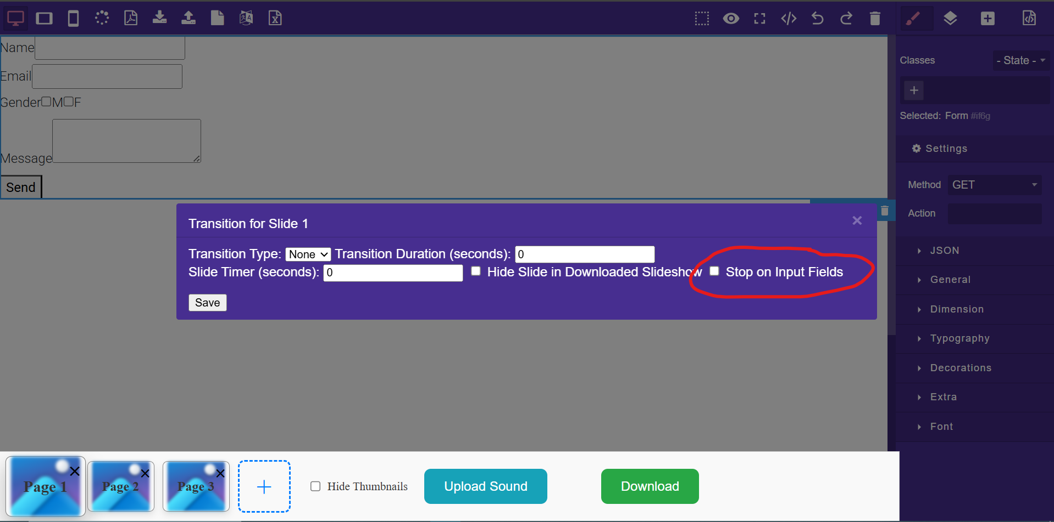

14. Slide Music (Per-Slide Audio)
In the transition modal, you’ll find a checkbox:
☐ Add Music to This Slide
Once ticked, a file upload option appears to attach an .mp3 or .wav audio file (max 5MB) to the current slide.
Additional options:
- Play Once: Plays music one time during the slide.
- Loop: Repeats until slide transitions.
In the downloaded slideshow, this music begins playback when that slide becomes active.
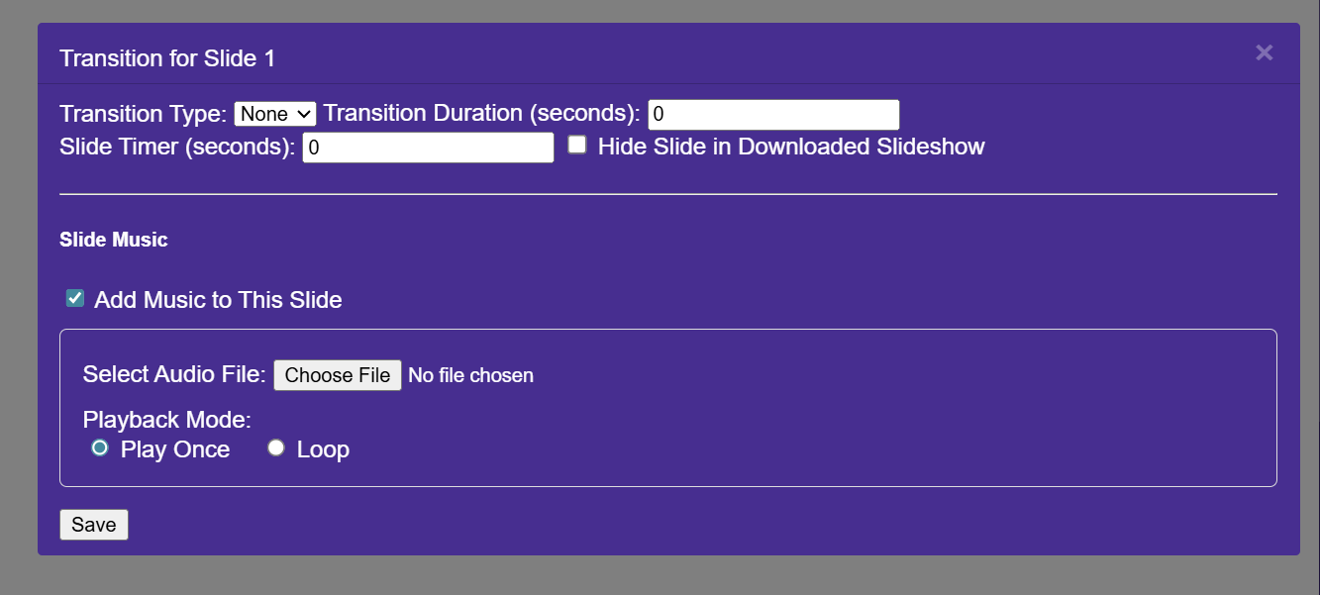

15. Background Music (Global Audio)
To set a background track for the entire slideshow:
- Navigate to the Slideshow Settings
- Add a server URL to an audio file, or use a relative local path (if embedding locally)
- File formats supported: .mp3, .wav
Important: If using a local file, ensure it matches exactly in name and folder structure — any mismatch will prevent playback.
The background music plays in loop across slides and pauses only when the user clicks the Pause button.

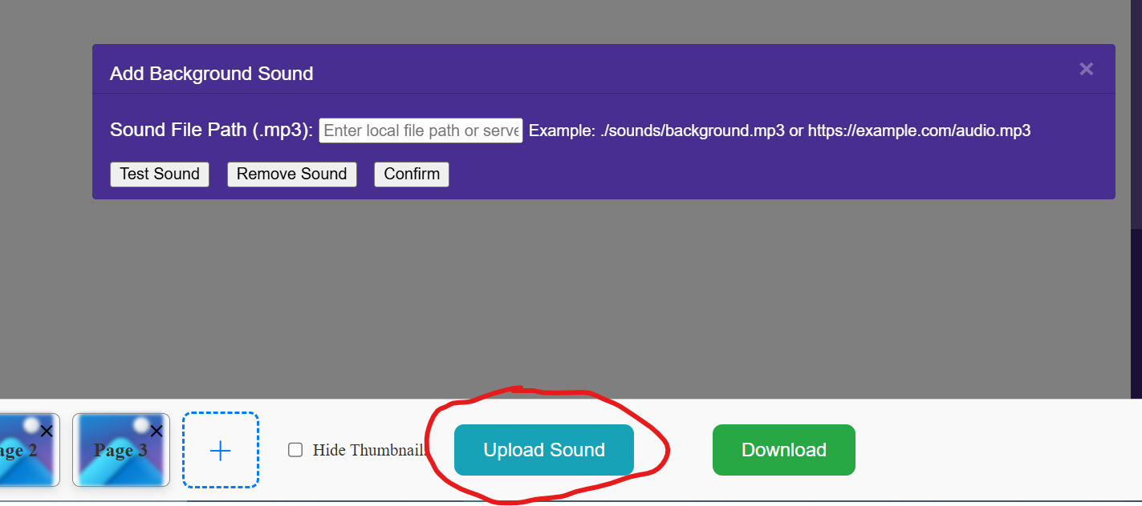
16. Drag-and-Drop Input Selector Component
A new drag-and-drop input field component has been introduced to simplify user input selection through a visual interaction method.
This component consists of:
- Multiple Buttons representing available options
- A dedicated Input Drop Area (text field) where users can drag and drop any button to select that option
How it Works:
- From the Form section, drag the component named “Drag-and-Drop Input Selector” into any slide.
- This component displays a set of pre-defined draggable buttons (e.g., Option 1, Option 2, Option 3).
- Users can click and drag any button, then drop it into the input area (a styled text field).
- Upon drop, the button’s value is automatically assigned to the input field.
- This selection can then be used as part of any POST logic (like described in Point 12) for filtering or API-based submissions.
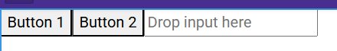

Backend Setup
Note: API URLs used inside form.js must be updated if deployed externally — look for the comment "need to change API here" in the script.

1. What Software Do You Need?
1. MySQL Workbench - To create and manage the database
2. Java JDK 17 - To run Java code
3. Eclipse IDE - To open and run the Java project

3. How to Install the Software
1. MySQL Workbench:
- Download from: https://dev.mysql.com/downloads/installer/
After completed ,
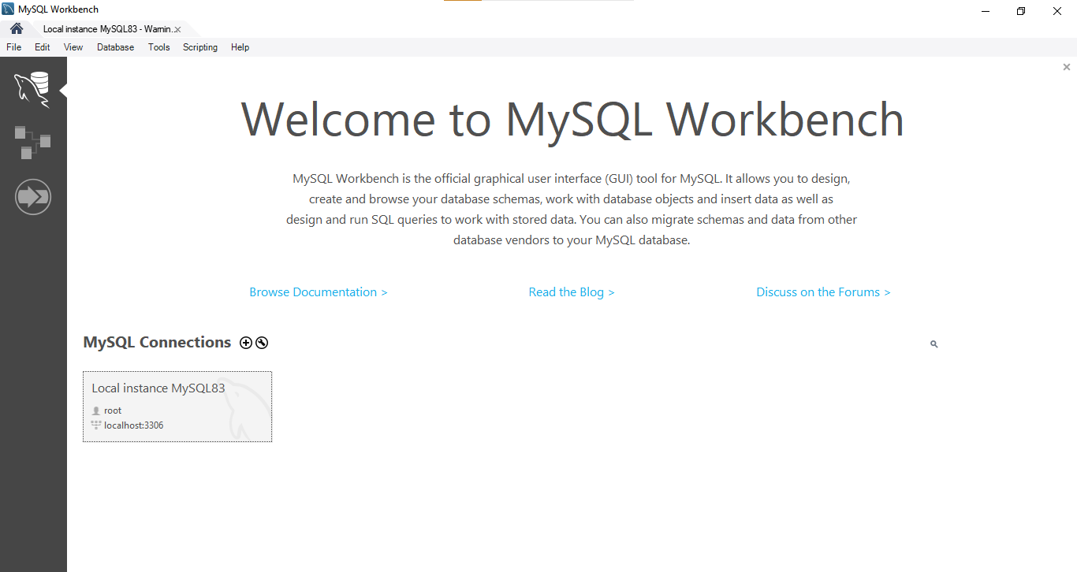
Click plus icon, and than enter the credential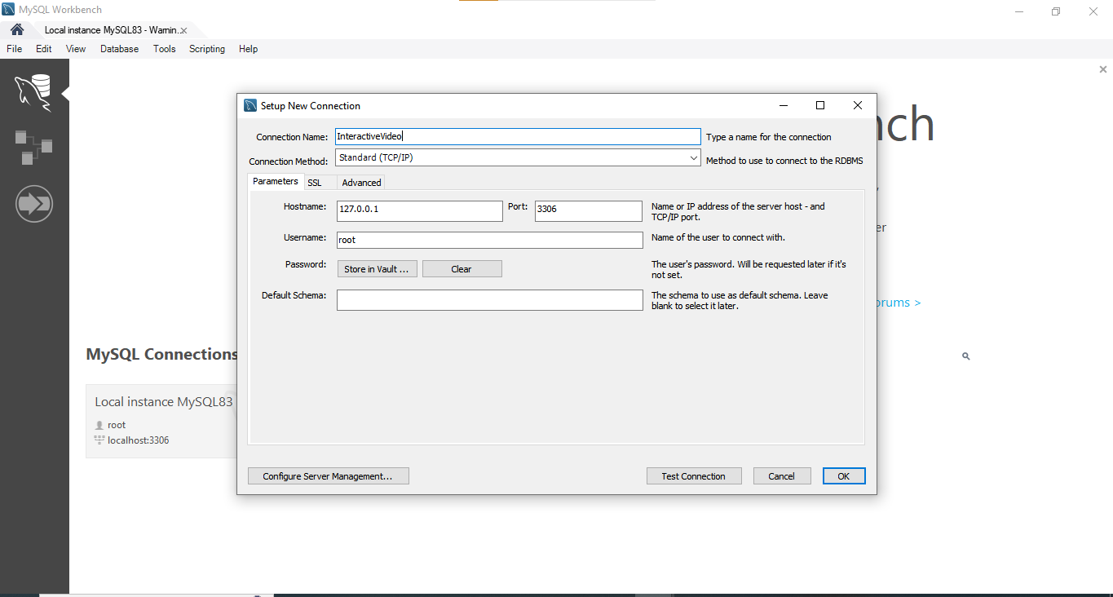
- During setup, set username = root and password = root
After the filling the credential and then test the connection and if connection is successfully than click ok button.
- Open MySQL Workbench :
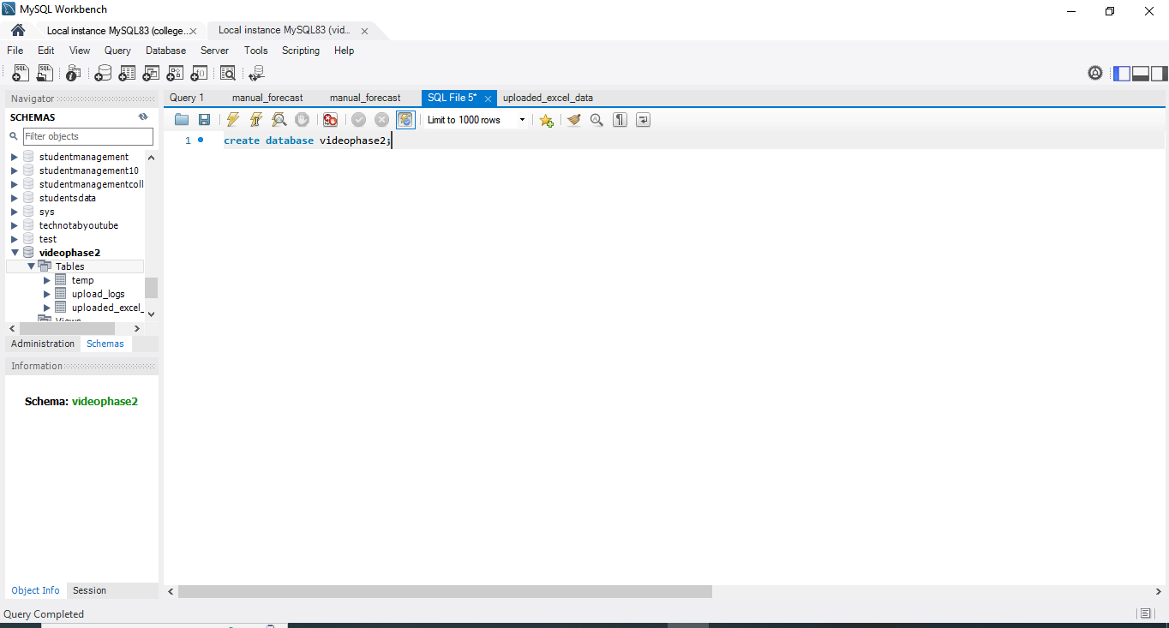
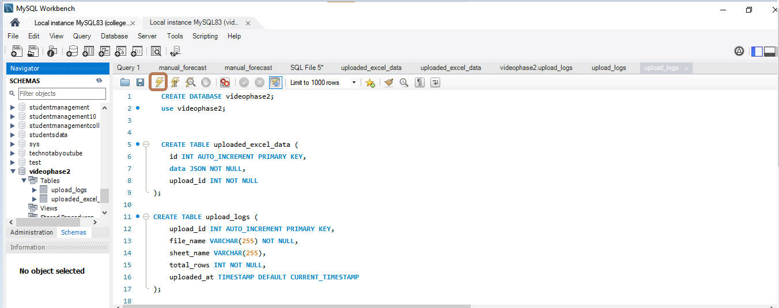
Create schemas and write :
1)
CREATE DATABASE videophase2;
use videophase2;
Click this icon which I mention in circle BOX , And excecute the query, and again write
CREATE TABLE uploaded_excel_data (
id INT AUTO_INCREMENT PRIMARY KEY,
data JSON NOT NULL,
upload_id INT NOT NULL
);
And again click above icon which I mention in circle BOX and excecute the query .
And again write
CREATE TABLE upload_logs (
upload_id INT AUTO_INCREMENT PRIMARY KEY,
file_name VARCHAR(255) NOT NULL,
sheet_name VARCHAR(255),
total_rows INT NOT NULL,
uploaded_at TIMESTAMP DEFAULT CURRENT_TIMESTAMP
);
Again click above icon which I mention in circle BOX And excecute the Query. See database is created.
2. Java JDK 17:
- Download from: https://www.oracle.com/java/technologies/javase/jdk17-archive-downloads.html
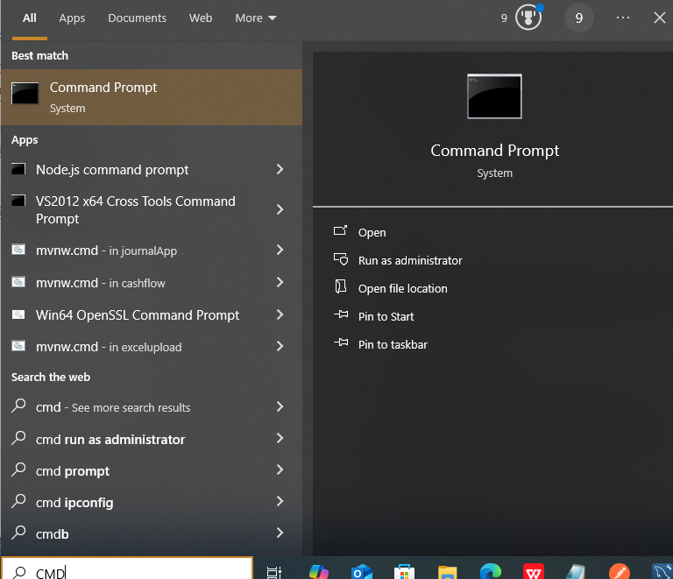
- Install it and check by typing 'java -version' in CMD
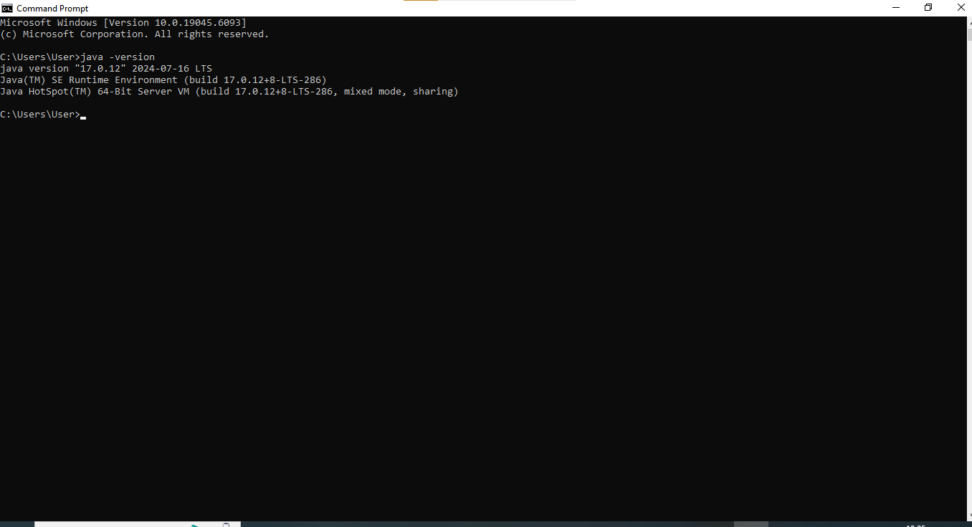
3. Eclipse IDE:
- Download: Eclipse IDE for Enterprise Java and Web Developers
https://www.eclipse.org/downloads/packages/
- Install and open Eclipse

4. Download, Unzip & Import the Project
Download the ZIP file of the project (you’ll get this from your trainer or GitHub)
Right-click → Extract All to unzip the folder
✅ Now Open Eclipse
Go to: File → Import → Maven → Existing Maven Project
Browse and select the unzipped folder
Click Finish .
Here are simple step :
Step 1:Go to File and than
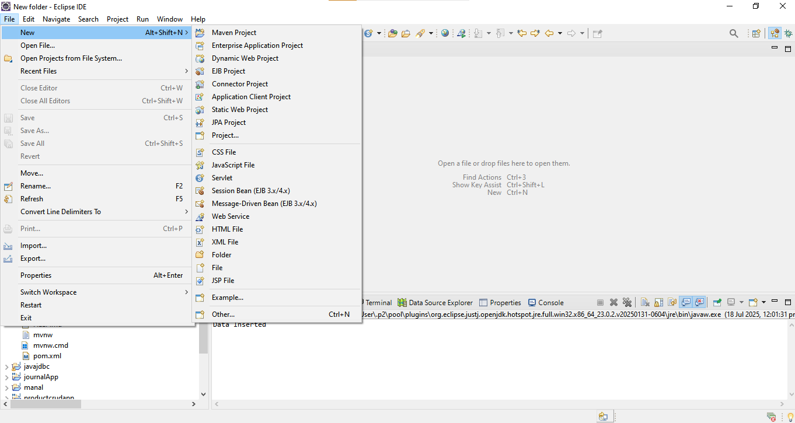
Step 2: select Import
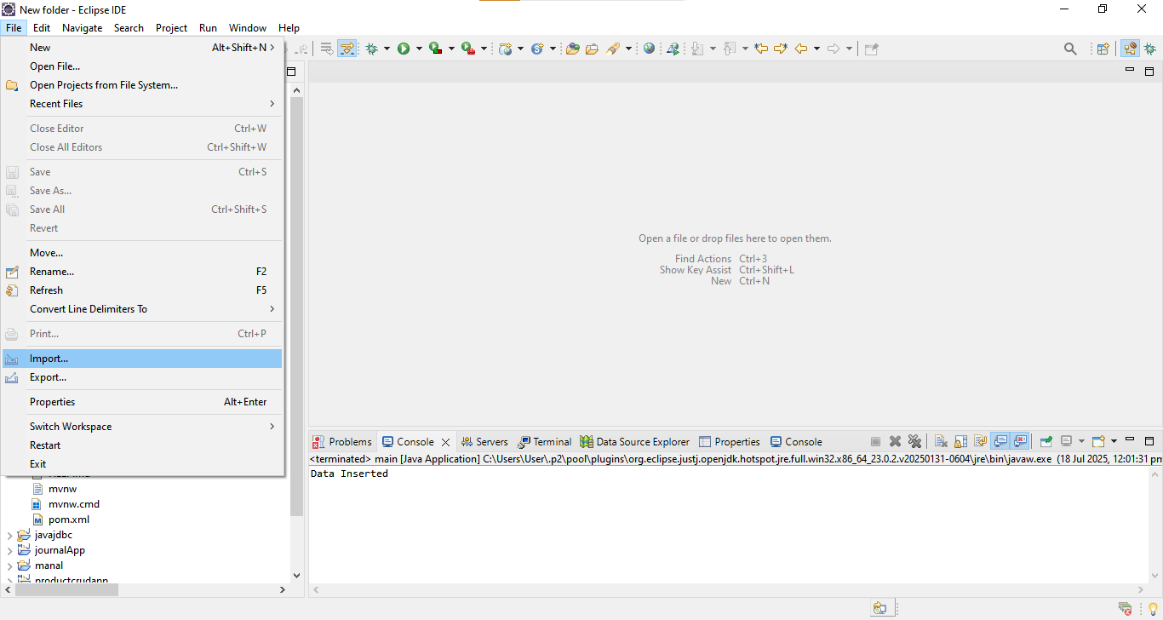
Step 3: Select Existing Maven Project..
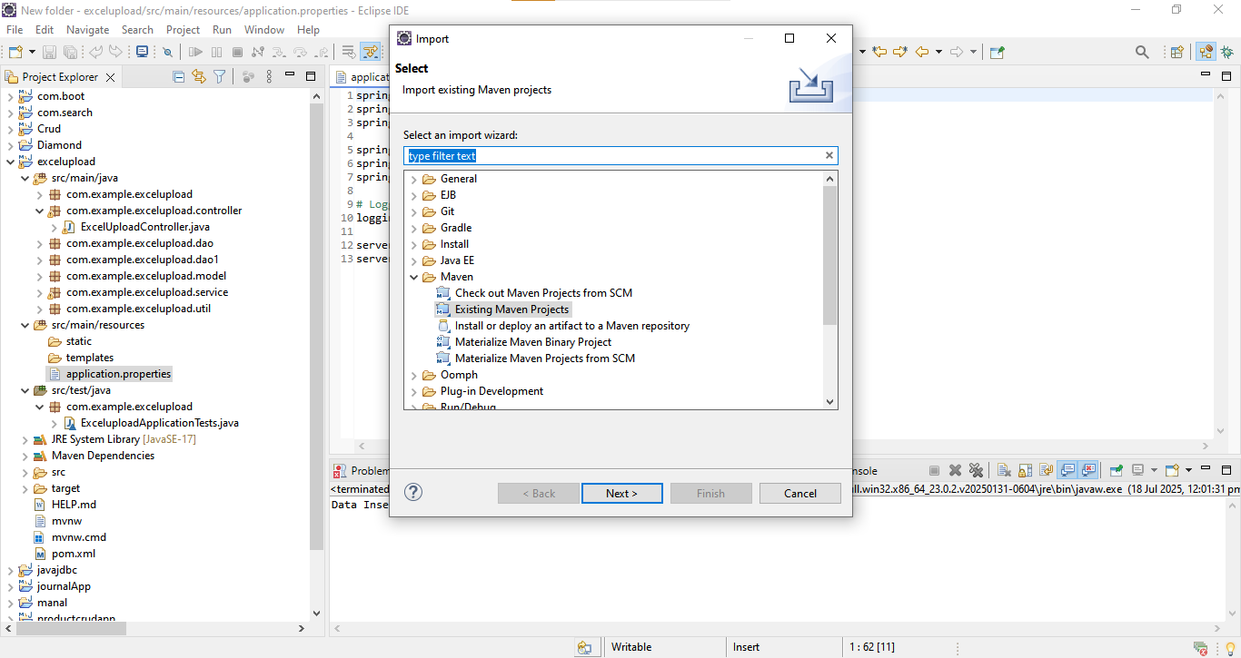
In Eclipse Open :
src/main/resources/application.properties and make sure these settings are correct:
spring.datasource.url=jdbc:mysql://localhost:3306/videophase2
spring.datasource.username=root
spring.datasource.password=root

5. Run the Project
- Go to src/main/java → com.example.excelupload → ExceluploadApplication.java
- Right-click → Run As → Java Application
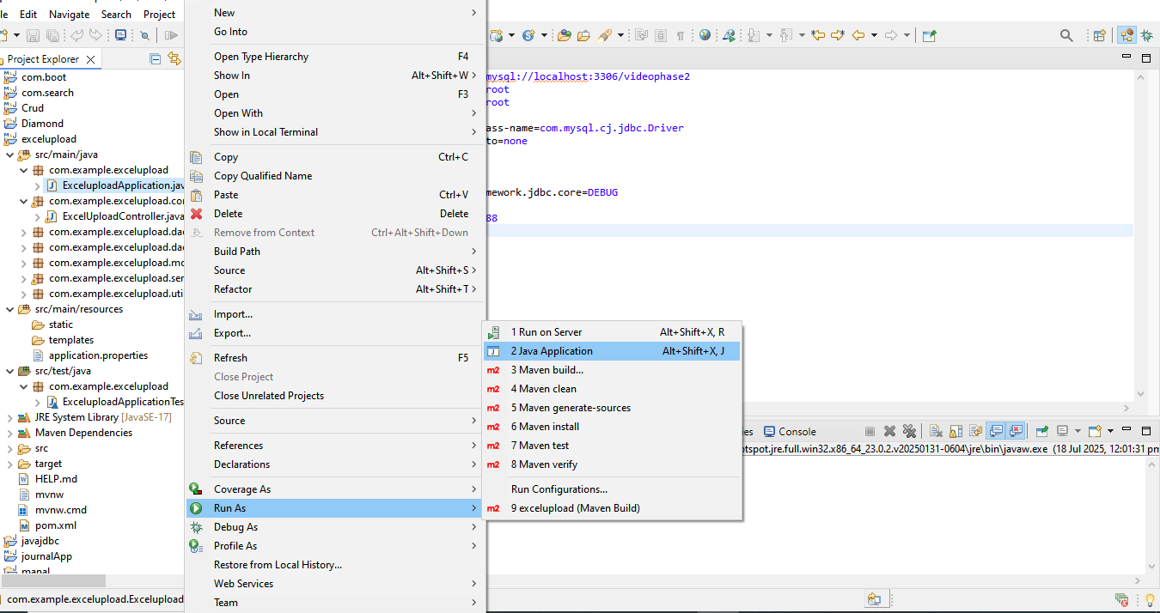
- Console shows:
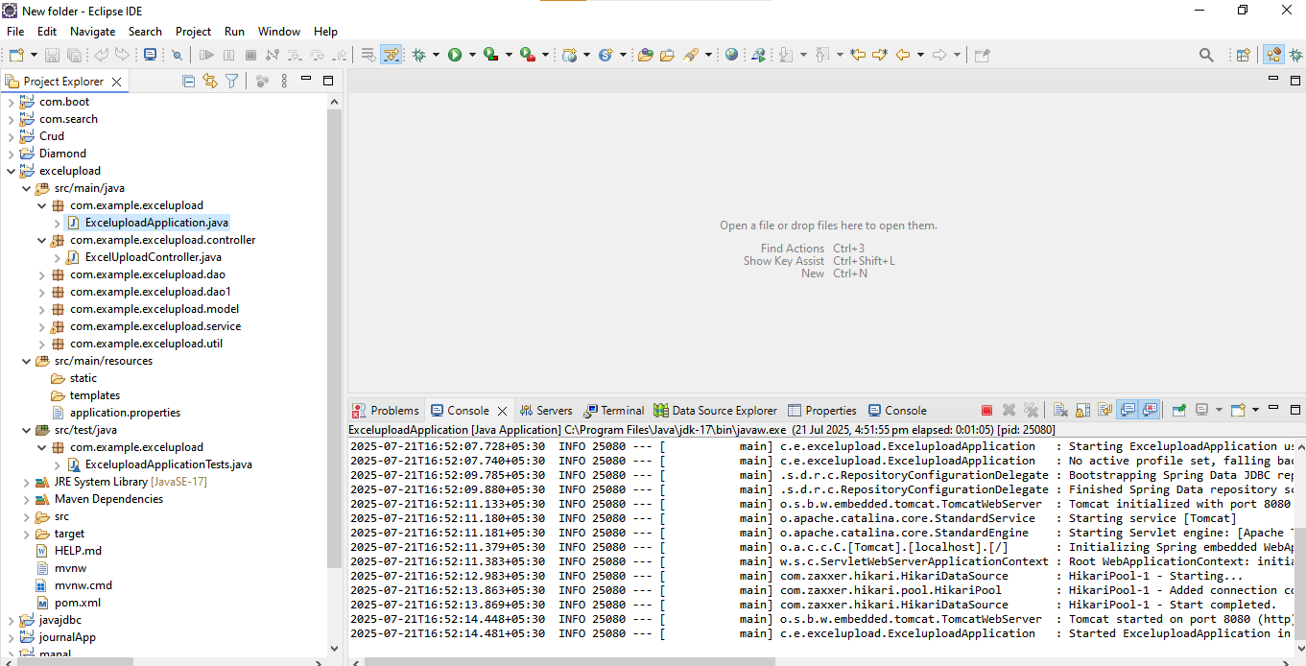

6. Common Errors and Fixes
- Port 8080 in use → Change port in application.properties
- DB connection error → Check DB name, username, password
- Excel not uploading → Check file format and data

Key Benefits
- Lightweight and fast: Perfect for interactive presentations, kiosks, or embedded use
- Supports internationalization and dynamic content via JSON
- Easy to extend, debug, and maintain as it follows modular architecture

Conclusion
The Interactive Slideshow Feature combines intuitive design with powerful transition and playback capabilities. Its modular integration with the existing project allows non-technical users to create and export highly dynamic presentations with ease.
Please refer to the accompanying screenshots for better clarity on each step. For further development or troubleshooting, feel free to reach out to the technical team.

